**INDEX**

**1.INTRODUCTION:**

* 1. **OVERVIEW:**

A brief description about your project.

* 1. **PURPOSE:**

The use of this project. What can be achieved using this.

**2. PROBLEM DEFINITION & DESIGE THINKING:**

**2.1. EMPATHY MAP:**

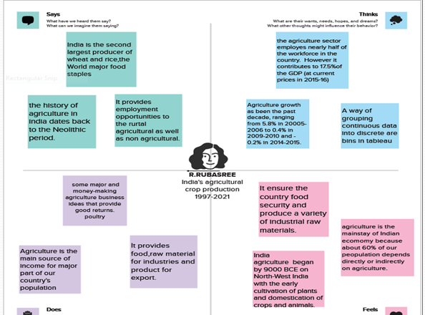

**2.2. IDEATION & BRAINSTORMING MAP**

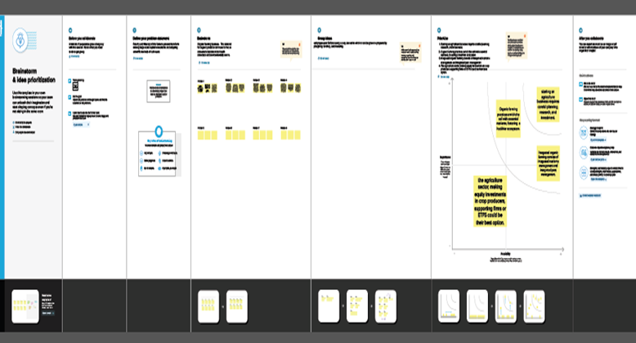

**3. RESULT**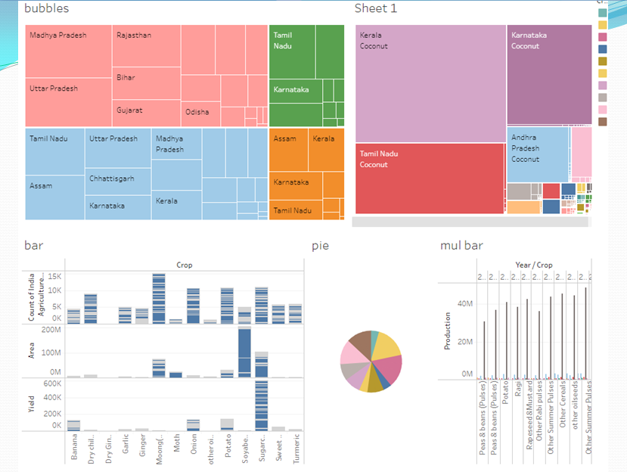

**4.ADVANTAGES & DISADVANTAGES**

**ADVANTAGES:**

* Increased Efficiency- Modern farming methods are more efficient than traditional methods, with advanced machinery and equipment, allowing farmers to produce larger quantities of crops in less time and with less labor.
* Improved crop Quality – The use of advanced techniques such as precision farming and genetic engineering has led to the development of higher quality crops that are more

Resistant to pests and disease.

* Reduced environmental impact – modern agriculture techniques are designed to be more sustainable, with a focus on reducing waste, conserving resources, and minimizing the use of harmful chemicals.
* Increased Food Production – Modern agriculture has enabled farmers to produce larger quantities of food, helping to address food shortages and hunger in many parts of the world.

**DISADVANTAGES:**

* Soil Degradation – The intensive use of modern farming practices, such as heavy use of chemical fertilizers and pesticides, can lead to soil degradation over time, reducing soil fertility and leading to erosion.
* Biodiversity Loss – Modern agriculture can have a negative impact on biodiversity, with the use of monoculture and genetically modified crops leading to a loss of natural diversity in plant and animal species.
* Water Pollution – The excessive use of chemical fertilizers and pesticides in modern agriculture can lead to runoff and contamination of nearby water sources, potentially harming aquatic ecosystems and human health.

**5. APPLICATIONS**

* With the help of our project, we can analysis all the cultivations happened between the specified years. So we can use the date from the analysis to predict the cultivation of crops that gives the maximum yield and high profit with respect to the corresponding seasons.
* Seasonality is the phenomenon that causes crop prices (including cash, futures, basis, option volatility, intra market, inter market, and inter-commodity spreads) to behave in a relatively predictable manner, year in and year out.

6. **FUTURE SCOPE**

* Agriculture in India is livelihood for a majority of the population and can never be underestimated.
* Although its contribution in the gross domestic product (GDP) has reduced to less than 20 per cent and contribution of other sectors increased at a faster rate. Agricultural production has grown. This has made us self-sufficient and taken us from being a begging bowl for food after independence to a net exporter of agriculture and allied products.